October Newsletter
Leader in Me Student Jobs Spotlight

The beginning of the year has been busy getting our student jobs organized! At the beginning of the year, your student(s) voted for their top jobs they wanted to be a part of and were placed in a student led group! This month we are featuring three student led jobs, which include safety patrol, fitness crew, and news crew.

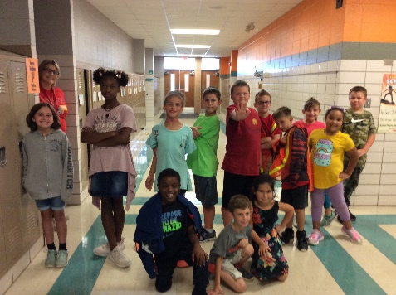
Safety Patrol

Safety Patrol members are responsible for greeting parents and students at the front doors and bus doors each morning from 7:30am-7:45am. Safety Patrol students will politely greet parents, visitors, and students each morning as well as hold the door open for them. In addition, they will monitor the halls and look for safe leaders!

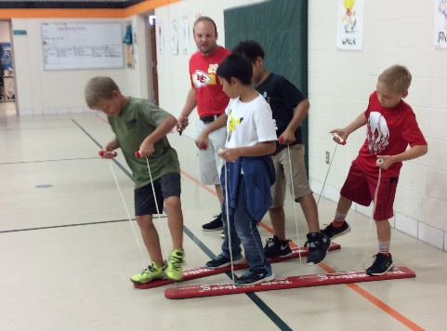
Fitness Crew
Photo of safety patrol students!

Fitness crew members meet in gym to engage in exercises to improve their health triangle. This will include participating in cooperative & team building activities; also lead dances/exercises during morning gym duty or assemblies, as well as lead warm-ups during PE.

News Crew
Photo of Fitness Patrol Students!

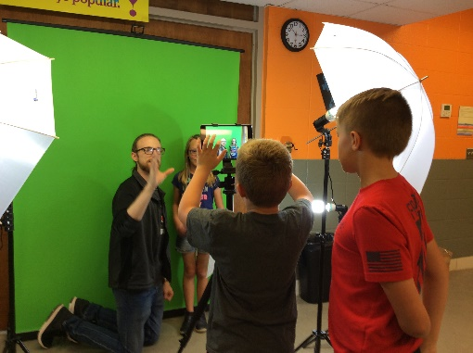
News crew students report the weather and event updates for the month ahead. They will use a green screen and play on a loop during assemblies and on the TV in the front entrance.
Photo of News Crew Students!

